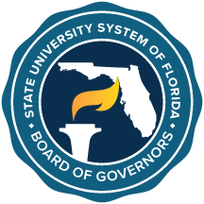

State University System
Florida Board of Governors
2024-2025 Legislative Budget Request Instructions

The Board of Governors will focus its Legislative Budget Request (LBR) on continued support and resources for the system.

Any system-wide request identified as a critical system-wide need should go through the appropriate system Council (CAVP, CSA, CAFA). For system-wide requests, consideration will be given to requests that allow for greater efficiencies through shared system resources or identified as a system-wide need. If requesting funds as such, please list all university participants of the initiative and check the box “Shared Services/System-Wide Issue.”

If a university is pursuing a university-unique budget request, the appropriate forms should be completed. These requests will be provided to the Board as information. Any requests unique to a branch campus or a special unit (e.g., IFAS Workload Initiative) should not be included in the main campus request, but reflected separately by use of the forms provided. For unique requests identified by a university, please check the box “Unique Issue for FY 2024-2025.”

Please keep in mind that all issues submitted for consideration by the Board should align with the goals and objectives of the strategic priorities and accountability plan established by each university.

The date of your university board of trustees’ approval (or pending approval) for the LBR must be included on the Form I.

