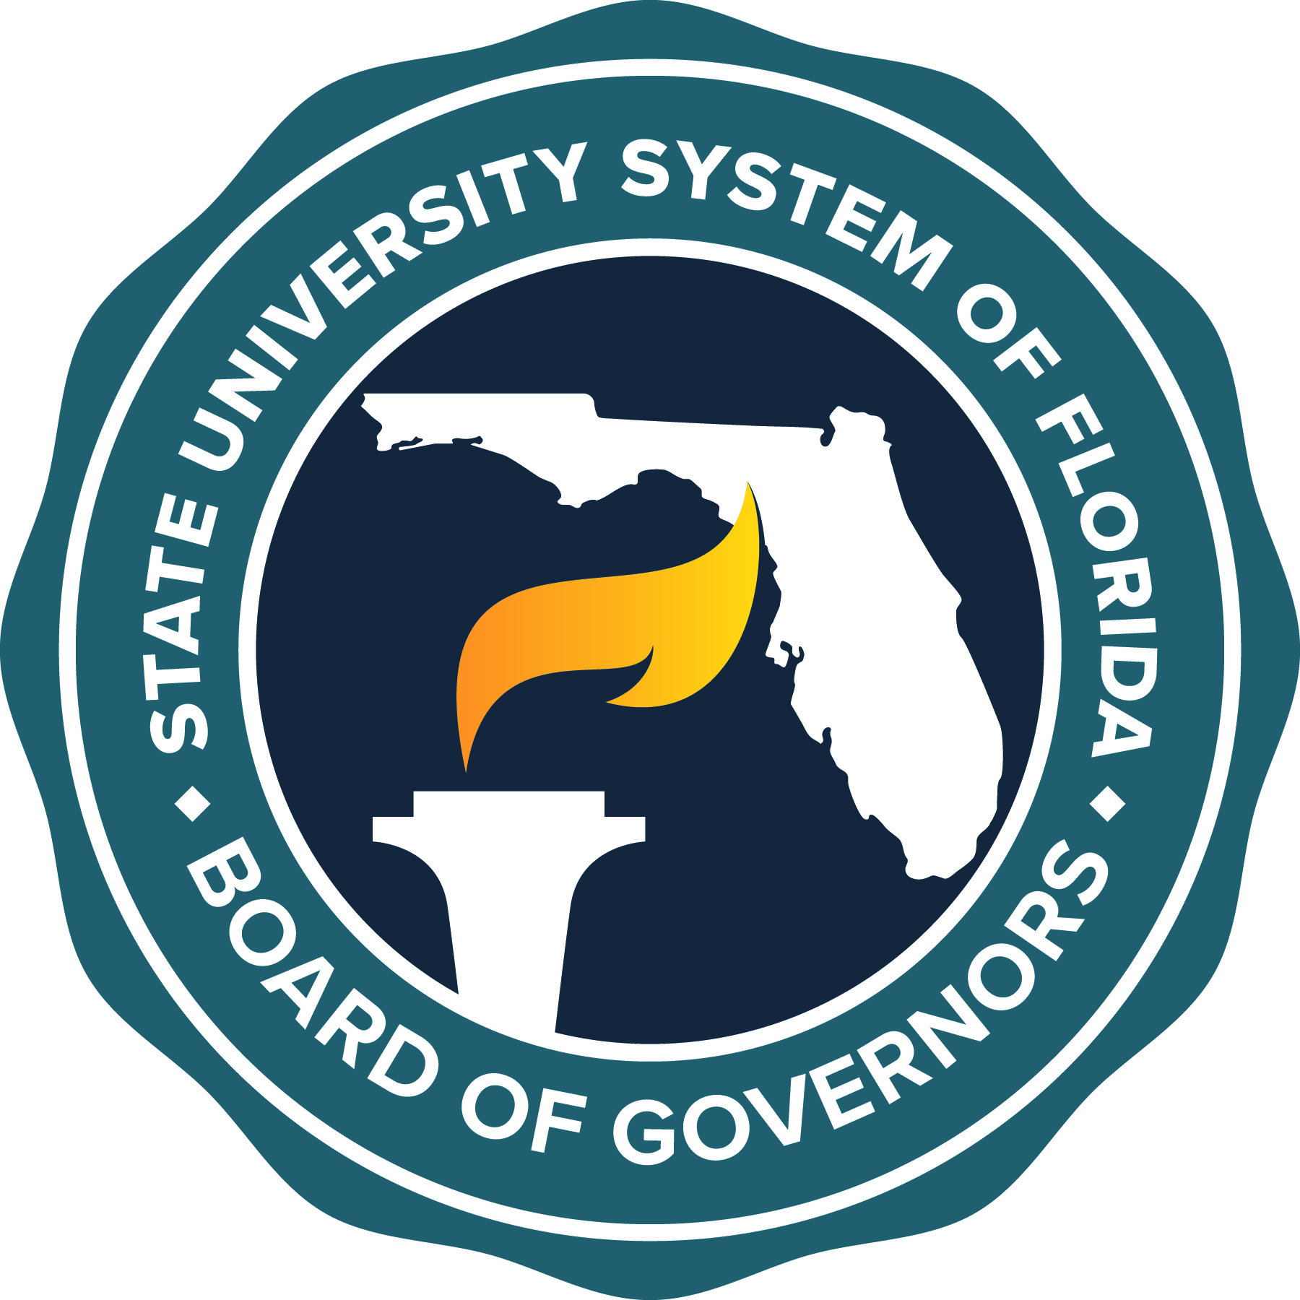

AGENDA
Innovation and Online Committee
University Conference Center
University of West Florida
11000 University Parkway
Pensacola, Florida 32514
September 14, 2022
9:00 - 10:00 a.m.
or
Upon Adjournment of Previous Meetings
Chair: Ed Haddock; Vice Chair: Darlene Jordan
Members: Diaz, Edge, Gabadage, Lydecker, Mateer, Michael

- Call to Order and Opening Remarks Chair Haddock
- Minutes of June 30, 2022, Committee Meeting Chair Haddock

- Preparing for a Post-Pandemic World in the Mary Banks
State University System: Chair
Shared Software Purchasing Plans SUS Chief Information Officers

- Ensuring Quality in Online Education in the SUS

- Professional Development Dr. Julie Golden-Botti
Assistant Provost
Online and Continuing Education
Florida Atlantic University

- Academic Integrity Robert Fuselier
Director, Office of Distance Learning
Florida State University

- University of West Florida Dr. Michelle Horton
Executive Director, Center for
Teaching, Learning, and Technology

- Florida Postsecondary Academic Library Network Tim Brown
Assistant Vice President
- Overview Information Technology Services
Florida State University
- 2023-24 Legislative Budget Request
- Concluding Remarks and Adjournment Chair Haddock

