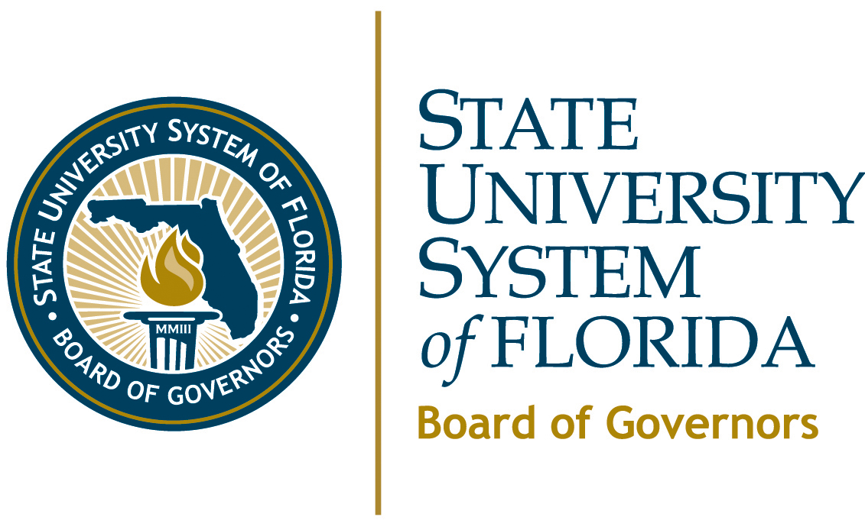

MEETING DATES AND LOCATIONS

2011
January 19-20
University of West Florida
Pensacola
February 17
(Conference Call)

March 23-24
Florida State University
Tallahassee
May 5
(Conference call)
June 22-23
University of South Florida
Tampa
September 14-15
Florida International University
Miami
November 9-10
Florida Atlantic University
Boca Raton
2012
January 18-19
University of North Florida
Jacksonville
February 16
(Conference Call)

March 21-22
Florida A&M University
Tallahassee
May 3
(Conference Call)

June 20-21
University of Central Florida
Orlando
September 12-13
Florida Gulf Coast University
Fort Myers
November 7-8
New College of Florida
Sarasota

