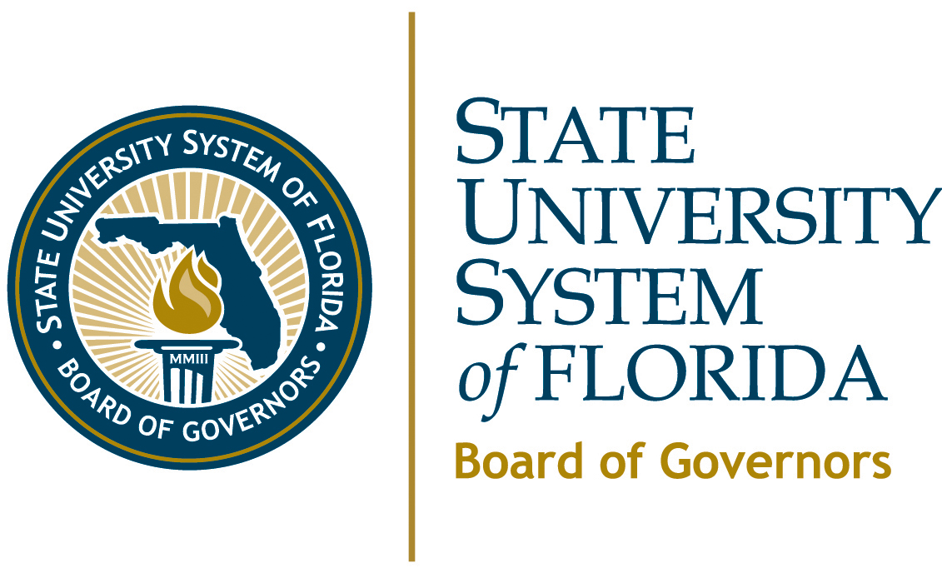

Coordination of Academic Program Delivery
Across the State University System

08/09/2010 Governor Ann Duncan and Chancellor Frank Brogan met with the Council of Academic Vice Presidents (CAVP) to discuss how to determine if there were better ways to coordinate academic program delivery across the State University System. It was decided that a small group of provosts, led by Ralph Wilcox, would work with the Board’s Academic and Student Affairs Committee on this analysis.
09/01/2010 Governor Duncan held an organizational conference call with the provosts’ workgroup. Although there are and will be numerous other efforts in the System to identify opportunities to share services for increased efficiency, this team will focus on reviewing System and institution data on academic degree program delivery, participation, and productivity at all levels. Recognizing that assessing the balance of productivity and quality is a complex task, the provosts will begin by analyzing data and identifying trends in the following areas:
- program enrollments,
- degrees awarded,
- student credit hours taken by program,
- methods of delivery (campus-based and on-line),
- recent program terminations and new program approvals,
- baccalaureate degree offerings in the Florida College System, and
- other areas, as appropriate.
The goal will be to determine if there are specific steps that can be taken to better organize and coordinate academic program delivery across the System.
09/15/2010 Board staff will provide an initial set of data to the provosts’ work group for review and discussion.
09/16/2011 Project expectations will be reviewed at the meeting of the Board of Governors Academic and Student Affairs Committee.
10/2010-TBA Conference call of provosts’ work group and Governor Duncan.
11/04/2010 The provosts’ work group will provide the Academic and Student Affairs Committee with findings from their initial analysis of the data, recommend any actions that can be taken for immediate benefit, and determine any other interim deliverables.
12/2010-TBA Conference call of provosts’ work group and Governor Duncan.
01/20/2011 The provosts’ work group will provide an interim report to the Academic and Student Affairs Committee.
02/2010-TBA Conference call of provosts’ work group and Governor Duncan.
03/01/2011 The CAVP shall submit a final report to the Chancellor, which includes a progress report of initial short-term actions/outcomes to date and outlines a specific plan for mid-term and long-term actions, with a focus on building out sustainable processes to ensure optimal coordination of academic program delivery across the System.
03/24/2010 The CAVP will report out to the Board’s Academic and Student Affairs Committee.

