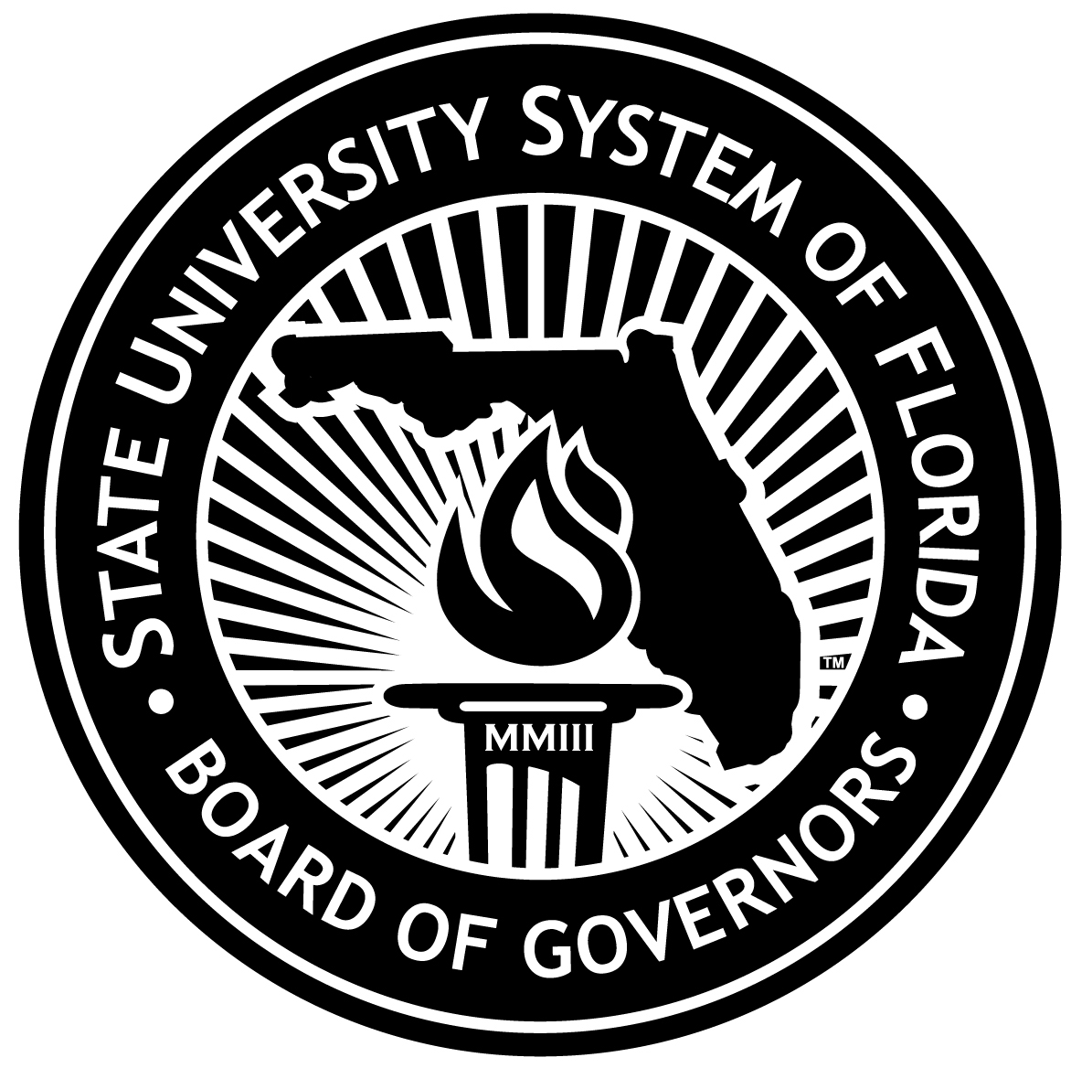

Major Gift Matching Program
2011-12 Legislative Budget Request

The Major Gifts Matching Grant Program enables the university foundations to receive state matching funds for private, endowed contributions to the university. Donations are required to benefit the library, instructional, or research capabilities of the university and be consistent with the university’s strategic plan to be eligible for matching under either program. Until matching money is paid by the state, many of the endowments on the priority list are incapable of fully supporting their stated objectives, such as scholarships, professorships, or Eminent Scholar Chairs, as the earnings on the private donations alone are not sufficient.
Private Donation |  |  | State Match
$100,000 | to | $599,999 | 50%
$600,000 | to | $1,000,000 | 70%
$1,000,001 | to | $1,500,000 | 75%
$1,500,001 | to | $2,000,000 | 80%
$2,000,001 | or | greater | 100%

The program was last funded in FY 2007-08, and an approved request backlog of $193,941,311 existed at the end of FY 2009-10. The following table illustrates both the growth of the backlog by year and the amount owed to each of the universities under the program.
 | 2006-07 | 2007-08 | 2008-09 | 2009-10 | Total
UF | $16,573,999 | $34,100,562 | $17,493,129 | $26,521,175 | $94,688,865
FSU | $443,732 | $11,128,182 | $8,809,888 | $10,382,149 | $30,763,951
FAMU | $75,000 | $498,643 | $0 | $0 | $573,643
USF | $137,057 | $12,994,204 | $3,568,757 | $2,678,733 | $19,378,751
FAU | $125,000 | $5,714,511 | $663,142 | $1,084,421 | $7,587,074
UWF | $420,000 | $107,382 | $795,896 | $270,129 | $1,593,407
UCF | $62,550 | $4,423,813 | $2,091,570 | $1,153,227 | $7,731,160
FIU | $276,230 | $8,455,005 | $1,534,335 | $8,813,845 | $19,079,415
UNF | $404,794 | $1,532,066 | $909,135 | $1,218,993 | $4,064,988
FGCU | $50,000 | $3,873,491 | $903,173 | $1,566,758 | $6,393,422
NCF | $0 | $1,195,212 | $313,923 | $100,000 | $1,609,135
Board | $0 | $0 | $250,000 | $227,500 | $477,500
Total | $18,568,362 | $84,023,071 | $37,332,948 | $54,016,930 | $193,941,311

Supports the Johnson Foundation matching gift program.

