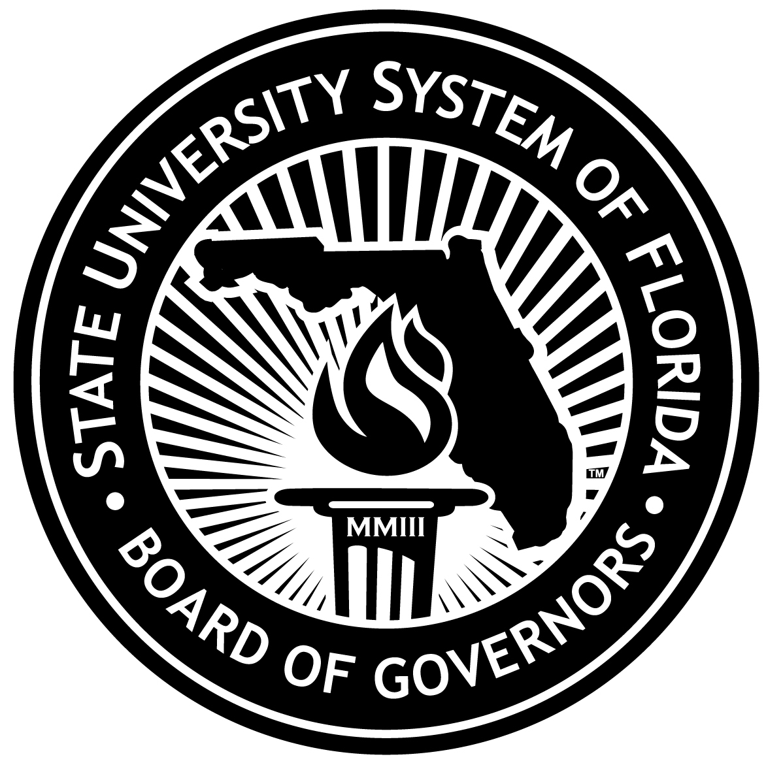
State University System
2011-2012 Legislative Budget Request Issues
Special Units and State Initiatives Budget

The following provides a brief explanation of the issues recommended for inclusion in the 2011-2012 Legislative Budget Request. Additional details for some issues are provided in subsequent attachments.

- New Florida Initiative (Special Units Only) - $41,078,165
  - Components of the New Florida Initiative for the Special Units include the following (additional details are included in Attachments 13a):
    - Medical School Support – An estimated $27.5 million has been proposed by the medical schools to expand in the area of dental care, increase programs and course offerings in health science disciplines, and attract/retain world-class scholars to enhance research efforts and opportunities. For example, the University of Florida – Health Science Center has requested $5 million to create a campus-wide program relating to environmental contaminates and toxicology. Emphasis will be placed on the long-term effects of the BP oil spill, as well as health risks of nano-materials, agricultural and industrial chemical residues. The university has also requested $5.8 million to establish the UF Health Science Simulation Center which will focus on the development of novel applications of technology in the education, training and assessment of healthcare students. The University of South Florida – Health Science Center (USF-HSC) proposes to partner with the University of West Florida (UWF) to provide UWF graduates with guaranteed pathway/admissions into the USF-HSC School of Physical Therapy & Rehabilitation Services on the USF Tampa campus. Funding in the amount of $600,000 is requested to enhance the academic strengths of the physical therapy program.

    - Expansion of Workforce and Research Efforts – $5.7 million has been proposed to conduct basic and translational research relating to Florida’s livestock industry, increase international recognition in renewable chemicals and fuels, and increase public understanding of agriculture and natural resources.

    - New Medical School Support - $4.4 million has been proposed by Florida International University – Medical School (FIU-MS) and the University of Central Florida – Medical School (UCF-MS) to continue the hiring plan and scheduled implementation of their medical programs according to the 10-year budget plans. FIU-MS is requesting $2 million to support an additional 80 students and UCF-MS is requesting $2.4 million to support an additional 80 students.

    - UF-IFAS Research & Extension Workload – University of Florida – Institute of Food and Agricultural Science (IF-IFAS) has requested $3.3 million to continue services via the workload delivery unit. UF-IFAS fulfills a unique institutional responsibility with extension offices co-funded and co-located in all 67 counties and 13 regional research and education centers in Florida. As the primary land-grant institution in Florida, UF-IFAS provides science-related solutions to maintain and expand the economic impact and environmental sustainability of Florida’s social, agricultural, and natural resources.

- 2010-11 Plant Operations and Maintenance (Phased-in Facilities) - $278,915
  - This is the balance of resources required to support the operational costs for 19,214 gross square feet of new E&G facility space that will become operational at UF-IFAS and UF-HSC during FY 2010-11.

- 2011-12 Plant Operations and Maintenance (New Facilities) - $575,471
- During FY 2011-12, the State University System expects to increase its E&G Special Unit facilities inventory by more than 61,148 gross square feet. New facilities for UF-IFAS and UF-HSC that will be completed based on the contract substantial completion date during 2011-2012 and that have been approved for construction or acquisition by the Legislature are included in the new facilities issue request.

- 2011-12 Plant Operations and Maintenance (Base Adjustment for Existing Facilities - $2,260,723
  - A recommendation was made by the Facilities Task Force and approved by the Board of Governors at the June 19, 2008 meeting to request an inflationary increase for operating funds for existing space similar to the increase applied to funding for new space each year. This request represents the increase needed for existing facilities to support utility increases.

- Student Phased-In/Tuition Revenue - $3,580,000
- This issue provides budget authority to the medical schools indicated below based on estimated tuition revenue generated by a planned increase in medical students.
  - FIU-MS; $1,932,000 – 80 students are expected – bringing
the total to 160 medical students;
  - UCF-MS; $1,648,000 – 80 students are expected - bringing
the total to 180 medical students.

- Major Gifts Matching Program - $193,941,311 (Attachment 12)
  - This is the amount of requests for state matching funds received as of June 30, 2010. This program provides state matching funds to universities for private donations that establish permanent endowments with the proceeds of the investments used to support libraries, instruction, and research programs.

  - Outcome: Provides support for student scholarships, professorships, and endowed chairs.

- Moffitt Cancer Center - $1,200,000
  - Moffitt Cancer Center was created by the Florida Legislature and incorporated in 1984, as a not-for-profit corporation, dedicated to the mission of contributing to the prevention and cure of cancer. The state of Florida’s unwavering support for the Cancer Center has been a critical component of its rapid growth and success, and the Center is grateful.

  - An additional $1.2 million is needed to recruit and hire additional faculty for Moffitt’s Comprehensive Cancer Center Infrastructure and its Total Cancer Care database. Total Cancer Care is an ambitious partnership between patients, doctors and researchers to improve all aspects of cancer prevention and care. Patients participate by donating information and tissue. Researchers use the information to learn about all issues related to cancer and how care can be improved. Clinicians use the information to better educate and care for patients. This approach will provide evidence-based guidelines to improve care and outcomes for cancer patients throughout the state of Florida and beyond. Total Cancer Care addresses cancer as a public health issue and encompasses all aspects of the disease, including preventive measures such as the study of genetic predispositions, impact of health lifestyles and integrative medicine. Total Cancer Care follows the patient throughout their life, including screening, diagnosis and treatment of cancer. Translational research is incorporated at each step along this continuum of care and follow-up.

- Institute of Human & Machine Cognition (IHMC) - $1,497,047
- For the 2011-2012 LBR year, IHMC is requesting close to $2 million to enhance and grow its current operations at its Pensacola location and at IHMC’s new facility in Ocala, Florida.

- The additional funds will enable IHMC to continue to enhance its current research operations and expand in critical areas including advanced cognitive assistance technologies for wounded service members, network security, critical infrastructure protection and sustainable energy modeling and simulation in both Pensacola and its newest location in Ocala. Maintaining prominence in current research areas and developing strength in these emerging research areas are vital to IHMC’s continued growth and expansion and of critical importance to national defense, security and social needs.

