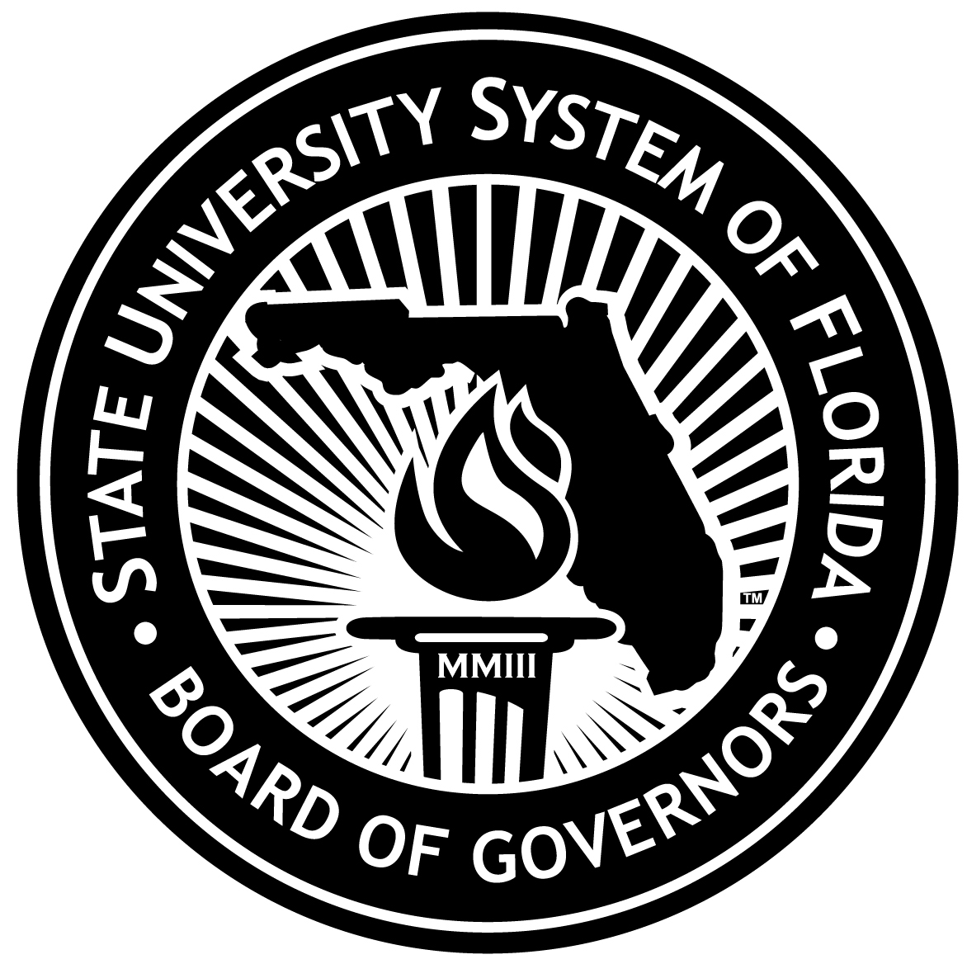

Florida Institute of Oceanography (FIO)
2011-12 Legislative Budget Request

The University of South Florida serves as the host institution for the Florida Institute of Oceanography (FIO), an Administrative Infrastructure Support Organization (AISO) approved by the Board of Governors and ratified by its 20 members (including all SUS institutions) under a Memorandum of Understanding. One of the objectives of FIO is to represent its membership in requesting support for ongoing programs and new initiatives in support of marine science research and education. FIO is seeking $7.2 million to: 1.) implement its State-wide responsibilities; 2.) stabilize and expand its administration, shared use resources, and member support; and 3.) establish it as the point of coordination for the SUS in coordinating and administering the academic research response to disaster events affecting the State, such as oil spills and hurricanes.
Because FIO is a relatively new organization (as an AISO) and because its mission is to serve the entire SUS, specific budget references may be expected at the BOG level. The importance of FIO and the need for this new initiative in disaster response has become evident since the Deepwater Horizon oil spill in the Gulf in April of this year.
FIO provides the infrastructure, administration, and coordination of shared use resources that enable all SUS institutions to excel in marine science research and education. It provides platforms and educational opportunities that promote collaboration among public and private educational institutions, non-profits, and private enterprise statewide, and brings regional, national, and international acknowledgement of excellence. It can increase the research capacity at SUS institutions and support specialized shipboard experiences in specific disciplines. As such, it supports new degree/certificate programs in the SUS and allows adoption of additional relevant degree and certificate programs, such as USF’s new Master’s and PhD program in Marine Resource Assessment and anticipated programs in ocean technology, aquaculture, and undergraduate marine science.
The availability of FIO resources will attract graduate students to marine science areas of study and motivate undergraduates to choose coursework that is qualifying for marine science-related Masters and PhD programs in the SUS. The marine research interests of FIO members are directly aligned with the fields of science, technology, engineering, and mathematics – the fields on which the knowledge and innovation economy is built and which produce the high-technology, high-wage jobs the SUS seeks for its graduates and for the State’s economy. As is demonstrated by the BP award of $10M to FIO to deal with the environmental impacts of the recent oil spill, it is to the State’s advantage to have a competent, coordinated response mechanism in place with outstanding human, physical, and technological resources ready to respond. The availability of well-trained graduates also attracts potential employers to Florida and can support spin-off companies and commercialization opportunities of the products of research to advance the Florida economy. The investment of State financial resources in FIO has both short and longer-term returns.

FIO will serve as the SUS coordinating body for ships, equipment, marine laboratories and other shared-use facilities and equipment. The FIO will plan, coordinate, and implement response to catastrophic events affecting the entire coastline, including the Gulf of Mexico. FIO will provide the necessary services to enhance the State University System’s shared use resources, expertise and infrastructure that sustain Florida’s coastal ocean research and education. The ability of FIO member institutions to work together to meet objectives has been and is being demonstrated by its response to the Deepwater Horizon oil spill and its ability to quickly undertake the research funded by the $10 million BP grant.

With the additional resources requested, the FIO will be expanded to provide the following:
- Research vessels at a reduced cost to member institutions, and other marine research institutions.
- Resources to member institutions, and other institutions for the lease and use of other research platforms.
- Opportunities to use a reconstructed and expanded Keys Marine Lab facility and program.
- State of the art video and satellite-enabled platforms for both research and education.
- Administrative support to Florida’s East coast member institutions.
- State-wide educational programs, community engagement initiatives, and degree program collaboration between SUS institutions.
- A data warehouse for ongoing research relating to Florida’s coastal ocean.
- Resources to member institutions for Cost-Share requirements on external awards, and faculty buy-outs for regional research opportunities relating to Florida’s coastal oceans.
- A virtual classroom for Florida’s students.
In accordance with the MOU, USF serves as host institution for FIO housed on the campus of the College of Marine Science in St Petersburg, Florida, where the R/V Bellows and the R/V Weatherbird II are home-ported. USF, through the College of Marine Science, is providing administrative and logistical support for the FIO including, but not limited to, reasonable office space with directly related support services, utilities, insurance, personnel services, purchasing, financial, legal, government relations/advocacy, physical plant services, and management of funded research and compliance.
The national and international reputation of USF and the other FIO member institutions in the marine research community, as well as the excellent reputation of USF and the other FIO members with Federal agencies, serves the AISO well.
FIO’s anticipated outcomes are as follows:
- Serve as advisor to the Governor, State University System Board of Governors, State Legislature, and others as requested, providing science-based advice on natural resource management, mitigation, regulation, programs and policy.
- Develop plan for coordinating rapid response of FIO members to assess and understand impacts on the Gulf of Mexico and Atlantic ecosystems and critical coastal ocean, estuarine and riverine resources of events such as hurricanes, oil spills, red tide and other harmful algal blooms.
- Administer resources provided to address impacts of disaster events, e.g., the $10M provided to FIO by BP to conduct research on the environmental impacts of the Deepwater Horizon Oil Spill of April 2010
- Ensure peer-reviewed documentation, widespread dissemination and interpretation of findings and recommendations to policy-makers, educators, and the general public.
It is expected that funding of the FIO initiative will support all SUS institutions in contributing to the dashboard metrics related to degrees awarded, Federal R&D expenditures, and other AAU and NRA metrics important to all institutions. Without FIO’s capabilities, member institutions may not be able to offer new related degree programs or attract the quality students – undergraduate, Masters, PhD, and post doctoral - desired.

