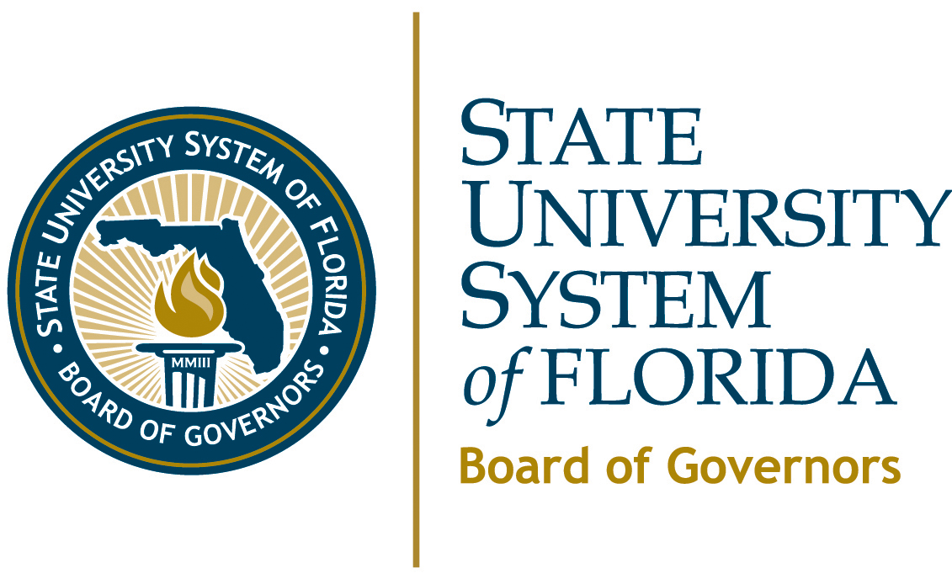 | Quick Facts  Planned New Degree Programs - 2010 to 2013

CHART 1: Summary of Planned New Degrees | Observations Regarding  Planned New Degrees  - 62 STEM Degrees.  - 11 Critical-Need Health Degrees.  - 5 Critical-Need Teacher Preparation Degrees.  - 5 Global Economics.  - 15 Business Degrees.  - 5 Digital Media-Related Programs.  - 23 Research Doctorates Primarily in Health and Science.  - 5 Professional Doctorates in Healthcare.  - 33 Duplicate Four or More Existing Programs in SUS.  - 70 New Programs for USF and Branch Campuses Equals 46% of SUS Total.
  Univ. | Bach. | Master’s | Spec. | Prof. Doc. | Research  Doc. | Totals
  FAMU | 2 | 5 | 0 | 2 | 1 | 10
  FAU | 0 | 3 | 0 | 1 | 1 | 5
  FGCU | 5 | 2 | 0 | 1 | 1 | 9
  FIU | 3 | 6 | 0 | 1 | 3 | 13
  FSU | 3 | 8 | 0 | 0 | 2 | 13
  UCF | 1 | 7 | 0 | 0 | 3 | 11
  UF | 3 | 3 | 0 | 0 | 4 | 10
  UNF | 3 | 3 | 0 | 0 | 0 | 6
  USF Tampa | 1 | 18 | 0 | 0 | 8 | 27
  USF St. Pete | 9 | 10 | 1 | 0 | 0 | 20
  USF Sar-Man. | 5 | 4 | 0 | 0 | 0 | 9
  USF Poly | 11 | 3 | 0 | 0 | 0 | 14
  UWF | 2 | 4 | 0 | 0 | 0 | 6
  TOTALS | 48 | 75 | 1 | 5 | 23 | 153

GRAPH 1: Planned New Degrees by University | GRAPH 2: Planned New Degrees by Level
SOURCE: 2010 University Work Plans

