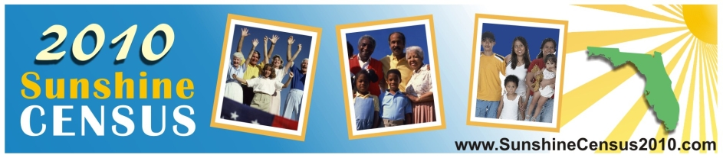

It is crucial that every person residing in Florida is counted during the 2010 Sunshine Census.
WHY?
Our involvement in the 2010 Sunshine Census is critical to Florida’s success, particularly as it relates to education funding.
When the census first began in 1790, its sole purpose was to determine the number of seats each state had in the U.S. House of Representatives.
Today, in addition to this purpose, the U.S. Census also affects the amount of federal funding received by the states, counties, and cities.
Parents, faculty, and students of all ages play a vital role in raising awareness about this important endeavor. By providing accurate information to the federal government, Florida students will benefit. In fiscal year 2000, 85 percent of federal government grants to state and local governments were distributed based on state population and personal income.
Every year, about $400 billion in federal funds are distributed to local, state, and tribal governments based on census data.

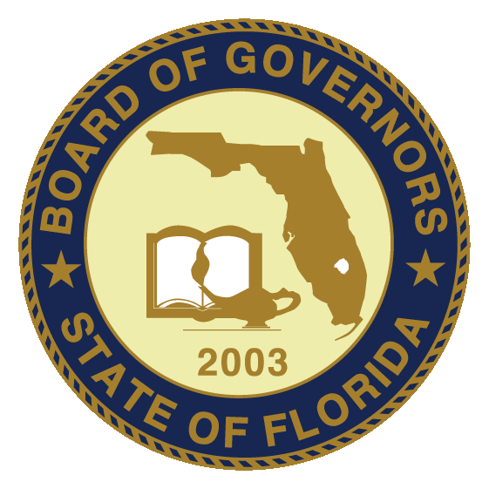

Sunshine Census 2010

Who is counted?

The census is a count of everyone residing in the United States: in all 50 states, the District of Columbia, Puerto Rico, U.S. Virgin Islands, Guam, the Commonwealth of Northern Mariana Islands, and America Samoa. This count includes people of all ages, races, ethnic groups – both citizens and non-citizens.
- The 2010 Census questionnaire has 10 easy questions for the head-of-household.
- For each additional person living in the household, there are seven of the same questions asked to the head-of-household. The simple, short questionnaire takes only minutes to complete and return by mail.
- Census information is very secure. Every Census Bureau worker takes an oath of confidentiality. Violation would result in a jail term of up to five years and/or a fine up to $250,000. By law, the Census Bureau cannot share an individual’s answers with anyone.

Important dates

Questionnaires are due by Census Day, April 1, 2010. Households that do not return completed questionnaire by mail will be visited by census takers between April 2010 and July 2010.
- The census takers will physically knock on the doors of households that did not respond to the initial mail-back questionnaire to obtain the required census information.
- By December 2010 the Census Bureau delivers population counts to the President for apportionment, the process of proportionately dividing the 435 seats in the U.S. House of Representatives among the 50 states.

Why Census taken?

- Census data is used to determine the need for social services, including community development block grants and other grant programs essential to many communities. The information also helps determine locations for schools, roads, hospitals, child-care and senior centers, and more.

Importance to Florida

- Florida’s population is diverse and changes seasonally.
- The people who reside in Florida are from many different backgrounds, speak many different languages, and may live here for only part of the year.
- In the 2010 Census, Florida needs to reflect its true population.
- In order to predict, plan, and receive the resources ($) necessary for Florida’s future, the 2010 Census needs to be as accurate as possible.

Canvassing

- Census workers will visit neighborhoods to verify housing units.
- This is the first census to include group quarters (such as dormitories, group homes, prisons and homeless shelters) in the address canvassing operation. This step should improve both the accuracy and coverage of the final count.
- Census workers will use hand-held computers equipped with GPS to increase geographic accuracy.

