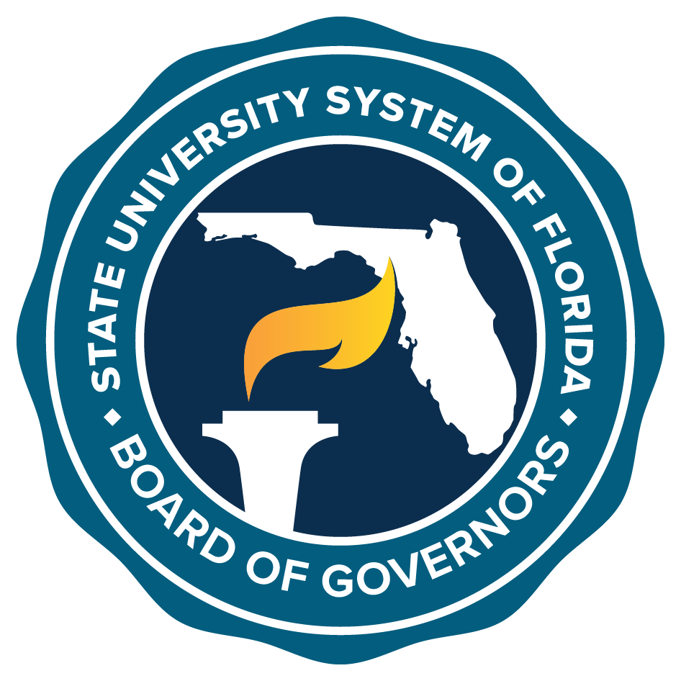
Trustee Summit Agenda
State University System of Florida – Leadership First
University of Florida, J. Wayne Reitz Union
October 29, 2019 Grand Ballroom, Salon C&D

8:00 a.m. Trustee Breakfast and Opening Remarks
Ned Lautenbach, Chair, Board of Governors
Syd Kitson, Vice Chair, Board of Governors

9:00 a.m. Trusteeship 101
Chancellor Marshall Criser III and Board of Governors Staff

10:45 a.m. (break)

11:00 a.m. Trusteeship 101 (continued)

12:00 p.m. Keynote Speaker and Lunch
Elizabeth Shenkman, Ph.D., Chair of the Department of Health
Outcomes and Biomedical Informatics and Co-Director of the
University of Florida Clinical and Translational Science Institute

1:00 p.m. Chairs’ Leadership Panel
Syd Kitson, Vice Chair, Board of Governors, Moderator
University Board of Trustees Chairs

2:00 p.m. Presidential Assessment and Development
Dr. Terrence MacTaggart
Association of Governing Boards of Universities and Colleges

3:00 p.m. (break)

3:15 p.m. Performance Funding and Financing University Facilities
Tim Jones, Vice Chancellor, Finance and Administration,
Chief Financial Officer
Chris Kinsley, Assistant Vice Chancellor, Finance and Facilities

4:30 p.m. Presentation by the University of Florida
Kent Fuchs, President, University of Florida
Mori Hosseini, Chair, University of Florida Board of Trustees

5:00 p.m. Remarks from the Honorable Ron DeSantis

5:30 p.m. Closing Remarks
Ned Lautenbach, Chair, Board of Governors

5:30 p.m. Reception

